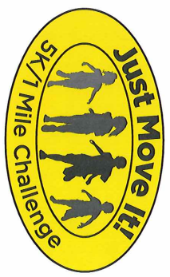

Just Move It! Challenge
T-Shirt and Poster Design Contest Entry Form

All Entries Due by 11/18/2016

- Top 3 t-shirt designs will be chosen from the entire district by the Just Move It! Challenge race team.
- District 25 students, faculty and family will vote for the winning design from 12/2/17 – 12/9/17
- Winning design will be on the race t-shirt and on the posters advertising the race at school as well as throughout Arlington Heights businesses.

Your First and Last Name: ____________________________

Circle the school you attend:

Dryden Greenbriar Ivy Hill Olive Patton Westgate

Windsor South Thomas
______________________________________________________________________________________________________________________________
_______________________________________________________________
_______________________________________________________________
_______________________________________________________________
_______________________________________________________________
_______________________________________________________________
_______________________________________________________________

***Be sure to staple this entry form to your drawing***
See the back for specific guidelines

T-Shirt Design Guidelines:
- 6th Annual Just Move It! Challenge must be in your design
- The date of the race is April 22, 2017
- Must be original artwork only. Please include your signature in your artwork (first name only)
- Design should be black and white only. Please draw with a black ink pen or sharpie.
- Design will be for the front of t-shirt only
- Design should be drawn on a white 8 ½ x 11 sheet of paper.

For a little inspiration, here is the winning design from last year:

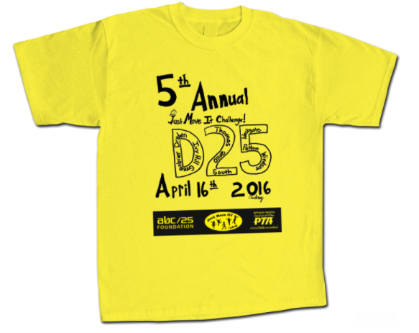

If you have questions concerning the rules, please send an email to jmichallenge@gmail.com. Please be sure to include “T-shirt Design Challenge” in the subject line.

